© Copyright 2020 Morpho Detection, LLC

7151 Gateway Boulevard, Newark, CA 94560 USA Tel: 510.739.2400

Fax: 510.739.6400

Title: CTX x800 DMT Tool Troubleshooting

### Document number:

Affected systems: CTX 5800/9800SEIO

Originator: Sean Yu

Revision date: 03/06/2021

## Introduction

The procedure describes the steps to troubleshoot DMT tool issue. Occasionally DMT tool may fail to launch. This is due to corrupted permission or files needed to run DMA tools properly. This procedure provides a quick reference to check and repair incorrect permissions and to replace missing/damaged DMT tool files.

## References

* + CTX 9800/5800 Postman Software User manual

## Definitions

* + HOST computer Main computer inside CTX
  + Remote Console Box A small control box that’s placed close to operator console table
  + CI computer Control Interface computer
  + Foot Pedal Switch A safety device that require operator input to
  + FSE workstation Service monitor and keyboard located on output left side of CTX

## Tools & Supplies

* + Small tools

## Procedure

## Verify edsconfigs.db and edserors.db permission

1. Log into CTX Host computer as geeds. Open a terminal window and become root (**sudo su**).Navigate to /var/eds/ folder. Type ‘**ll**’ (2 lowercase Ls). On the left-hand column, verify that permissions are: -**rw-rw-rw-** for both **edsconfigs.db** and **edserrors.db** files.

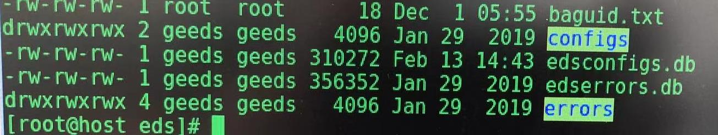

1. If this is not correct proceed to modify permission using the commands below:

* **chmod 666 edsconfigs.db**
* **chmod 666 edserrors.db**

1. Re-run the ‘ll’ command and verify correct permission. Try launch DMT tool and see if issue still exist. If not then proceed to RTS. If yes then proceed to replace damaged DMT tool files.

## Restore DMT tool damaged files

1. Request DMT Tool restore files from Smiths Tech support. Filename is dmt_tools.tgz.
2. Copy dmt_tools.tgz from USB flash drive to CTX host computer root diretory (**cp /run/media/geeds/USBDRIVENAME/dmt_tools.tgz /)**
3. Change current directory to root (**cd /)**
4. Delete existing files under tools directory (**rm -rf /tools/\***)
5. Restore DMT tool files (**tar xzvf dmt_tools.tgz**).
6. Launch DMT tool and verify functionality and RTS
7. If issue still persist contact Smiths Tech Support for further instructions.

## Cleanup

* Remove dmt_tools.tgz from root directory (**rm /dmt_tools.tgz**). Eject USB flash drive and perform RTS.